**Star Wars Shop**

**DB Design**

**Design Document explaining the code structure :**

The web application uses JSP and MVC framework for provided functionality.

**Snap Shot of Deployed Working Application :**



**Fig 1 : Index Page**

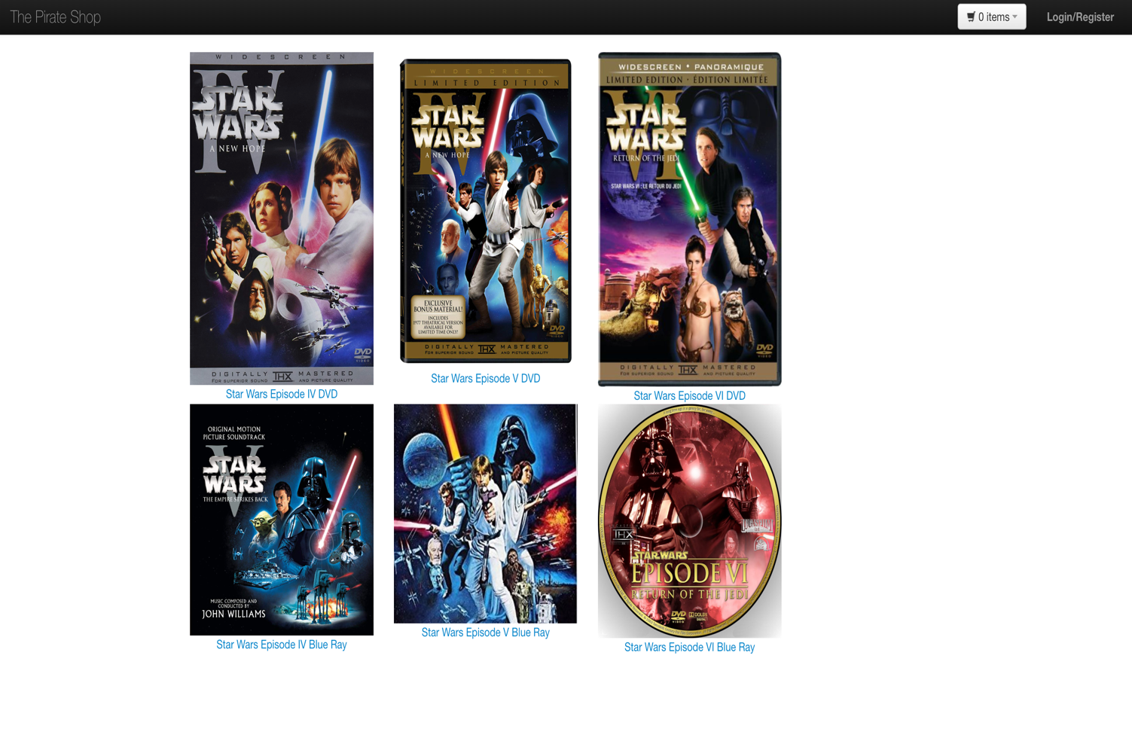**Fig 2 : Home Page**

**Fig 3 : Product Description Page**

Click on any Item link as Described in above Home Page and next Page will be shown as below

Describing the item

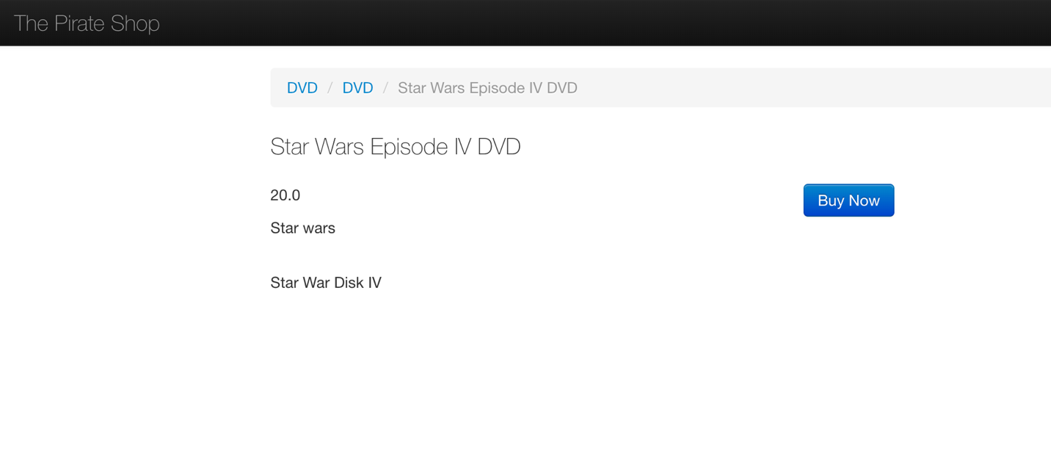

**Fig 4.1.: Add to cart Screen**

Click on Buy now to get The Add to Card Screen and Option to add to card with detailed description

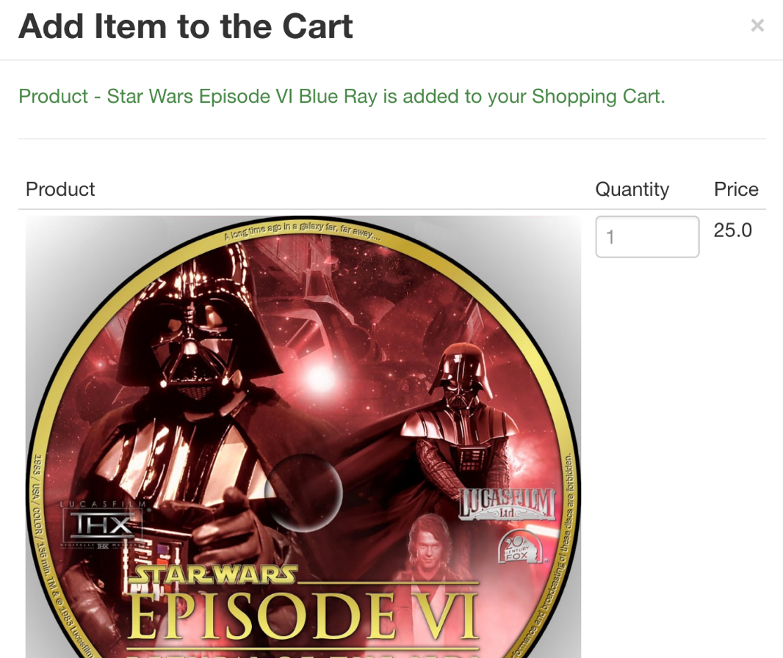

**Fig 4.2.: Add to cart Screen**

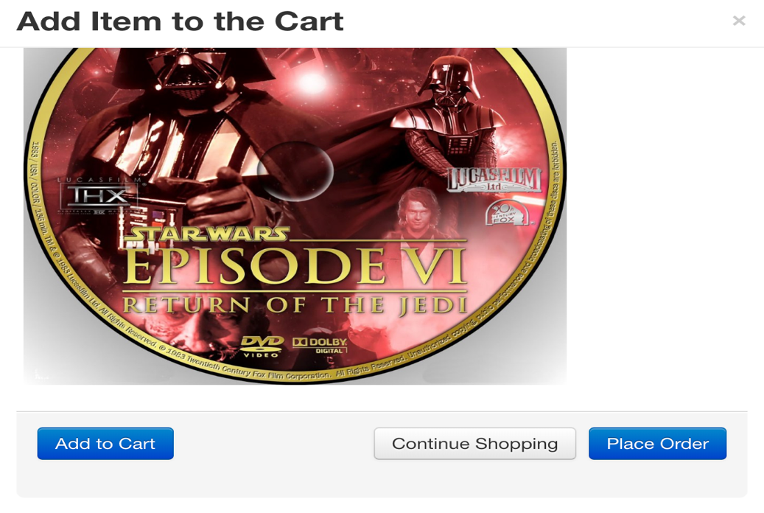

**Fig 5: Product Detail in Cart Screen ( Product with all details in cart along with price and checkout option)**

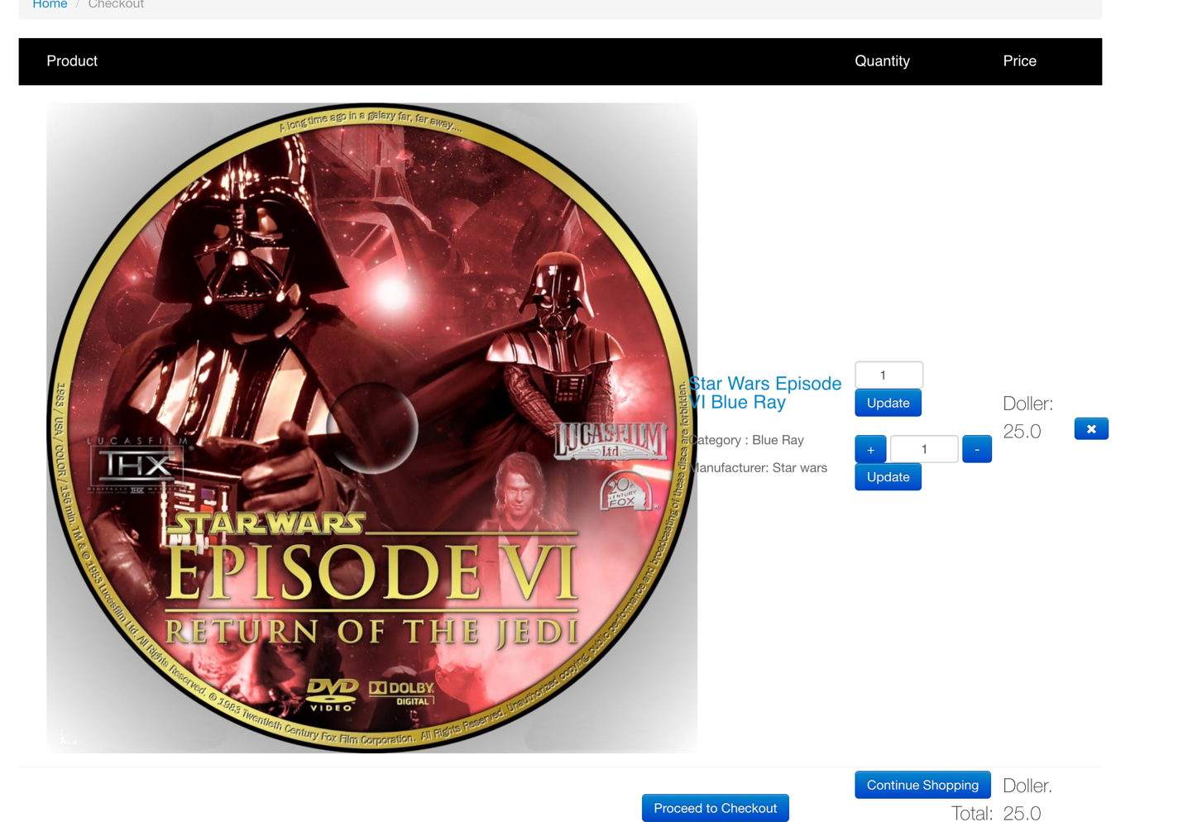

Click on Proceed to checkout to checkout the selected items and make review the order.

**Fig :6 : Login and Register Screen**

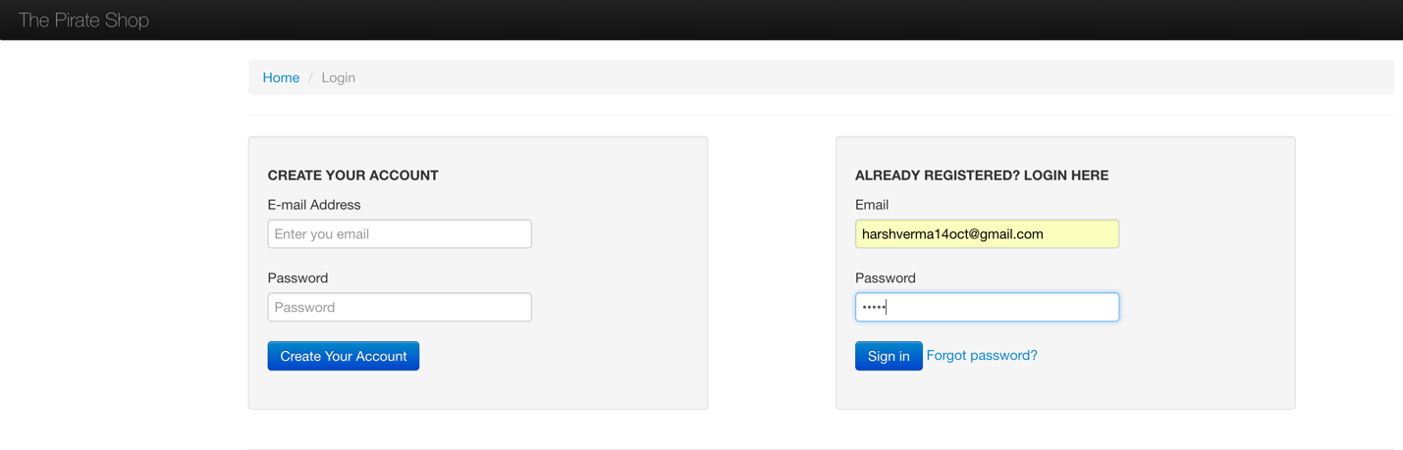

Login with username email as : [harshverma14oct@gmail.com](mailto:harshverma14oct@gmail.com)

Password : verma

**After Login you will be directed to Home page where clicking on cart again will take to Review screen:**

**Fig :7**

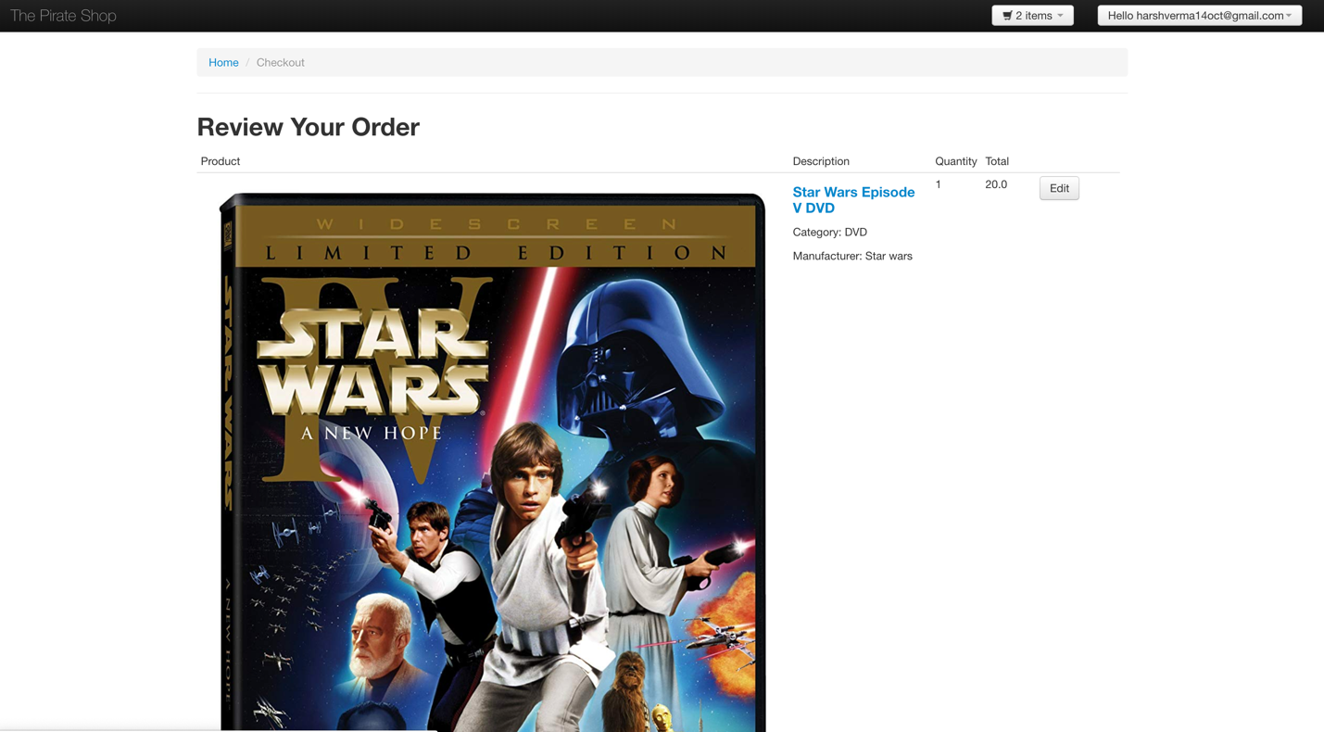

**Fig:7.2. Review Screen**

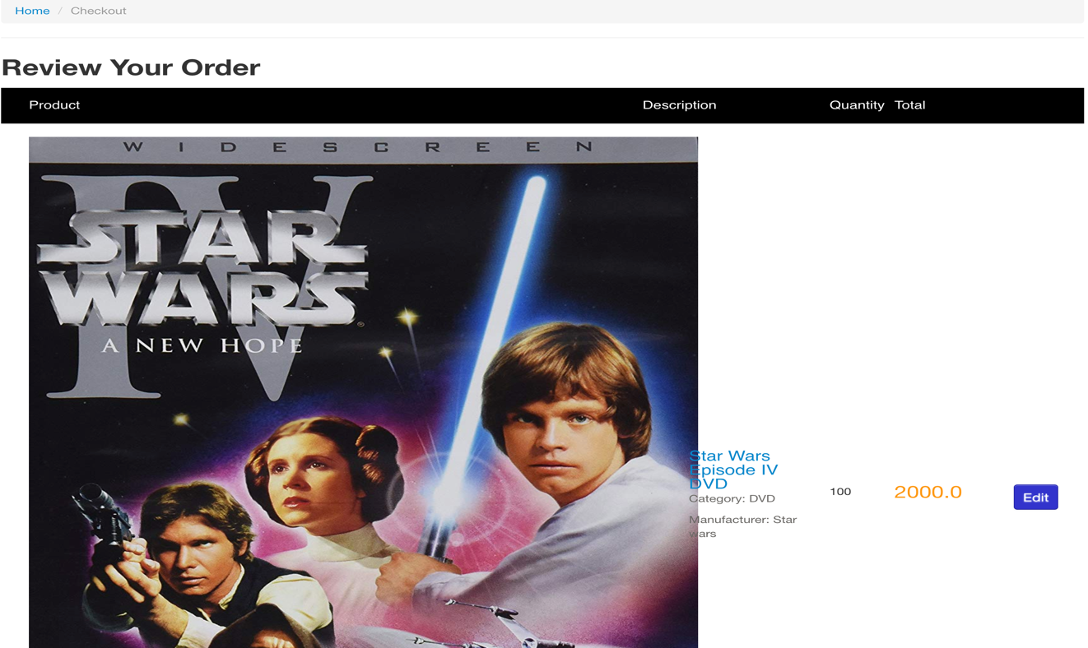**You can see the order selected in the review screen along with product image , prize and description and Discounted Prize of 5% if product items >= 100**

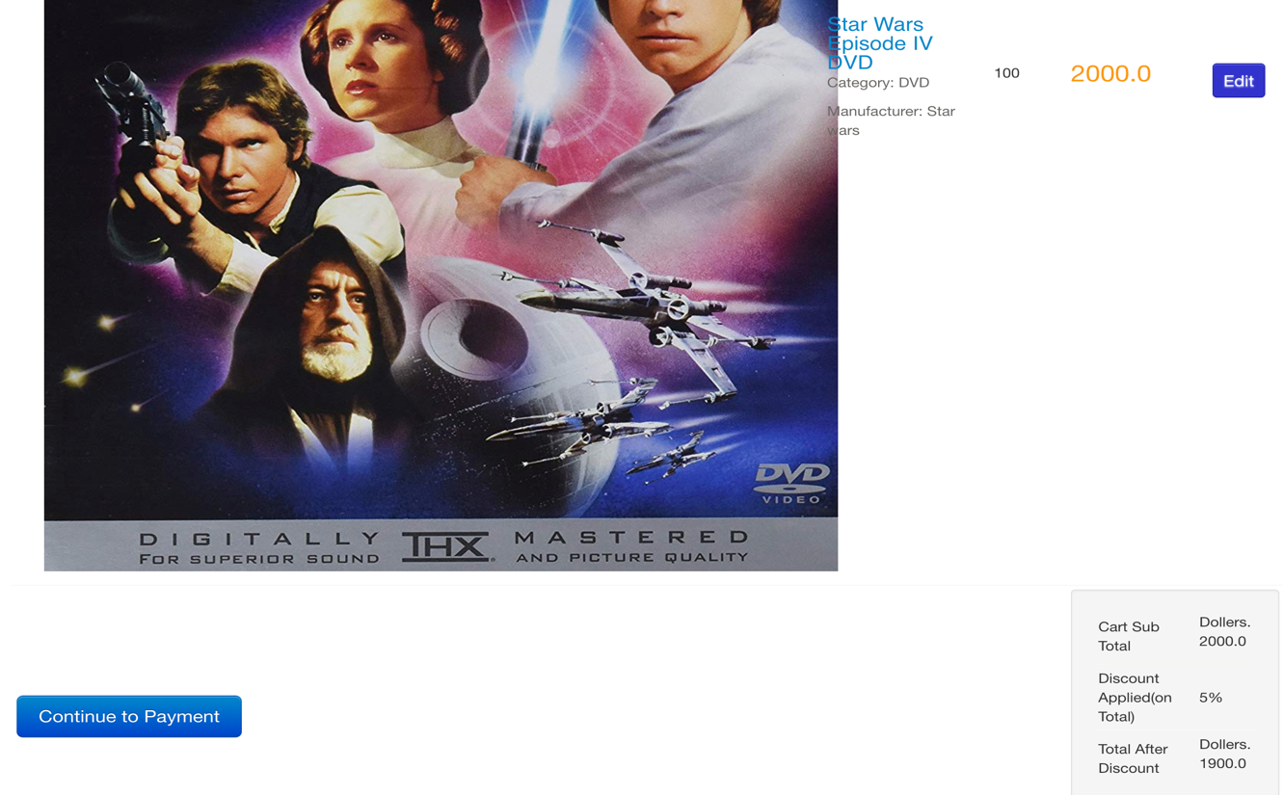

**Condition 2 : 5% Discount on total Prize is Applied if items are greater than or Equal to 100**

**Shopping cart Payment Screen : After final review the dumy master card payment is shown**

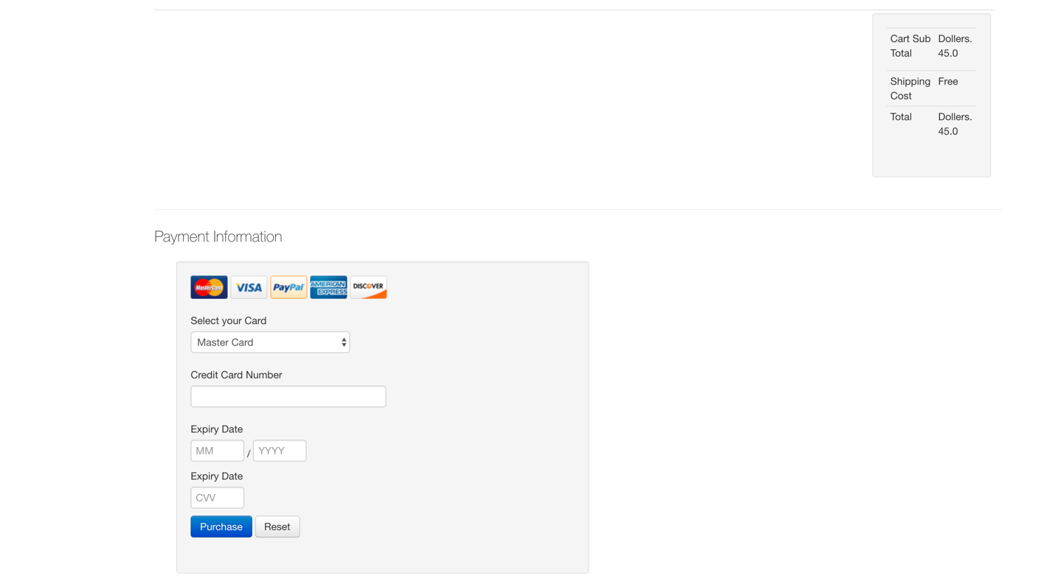**Fig 8**

**Fig 9: Click on purchase and reset Button and Dummy Card will take you to Final confirmation screen**

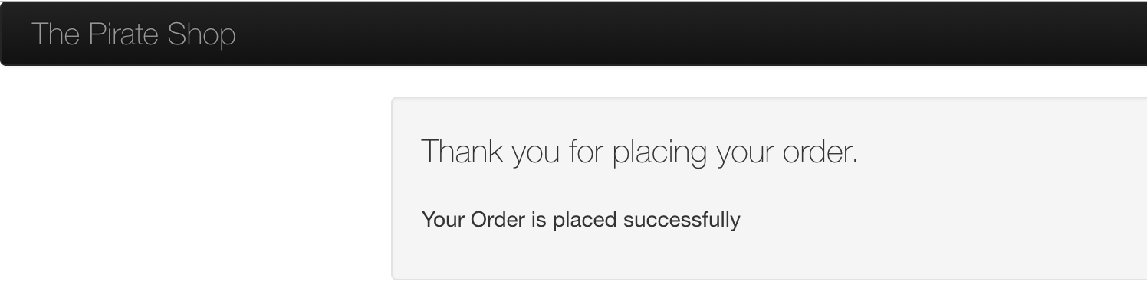

“**The Pirate Shop”** **Project Architecture :**

The architecture of project source diagram is described by image below

**Project Code Architecture :**

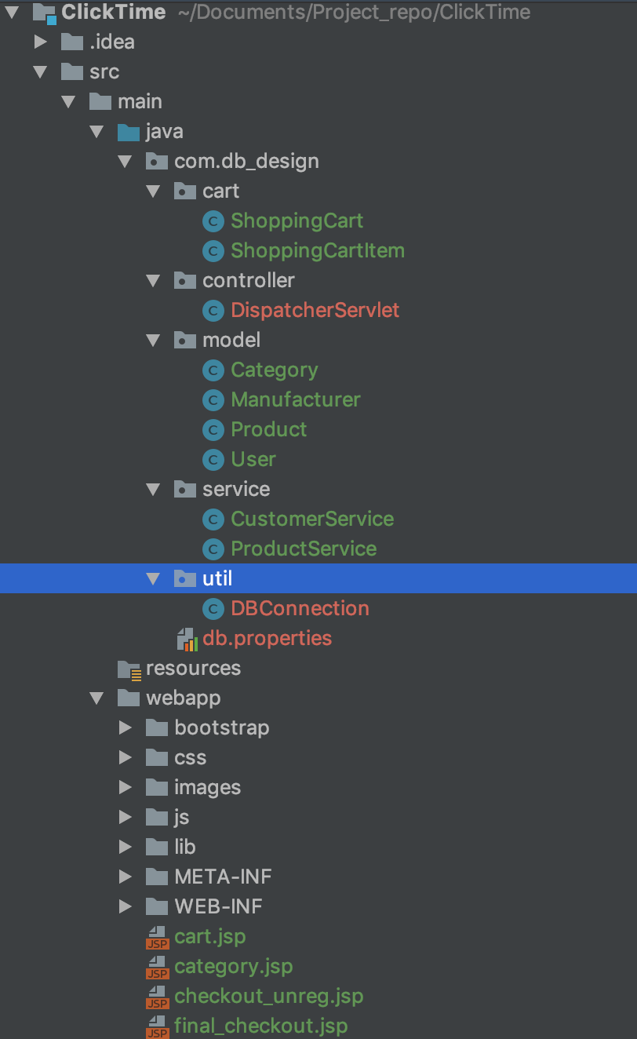

In this project, we will need the following tools: (The older or newer version should also works). Moreover, basic Java knowledge is assumed.

1. [Intellij](http://www.eclipse.org/downloads/) or Eclipse

2. [Apache Tomcat ver 7.0](http://tomcat.apache.org/index.html)

3. [MySQL Community Server and MySQL Workbench (GUI Tool)](http://dev.mysql.com/downloads/)

4. [MySQL Connector for Java](http://dev.mysql.com/downloads/connector/j/)

5. jstl.jar and standard.jar. You can get these jars from your Tomcat. Check in this directory : (your tomcat directory)—>apache-tomcat-7.0.26-windows-x86—>apache-tomcat-7.0.26—>webapps—>examples—>WEB-INF—>lib

Also the same jars are present in code web-inf/lib folder. The jars will be placed in web-inf -> lib folder and can be downloaded from java source directory from web.

6. JavaScript and CSS to make the view more user friendly.

**Project Design and way to Start :**

Go to Intellij. Before we create a new project for our application, we need to setup the server. Select File—>New—>Other. From the tree, Select Server.

Choose Apache—>Tomcat v7.0 Server and set the runtime environment.

Next, create a new project. Select File—>New—>Dynamic Web Project.

Enter “ClickTime” as the project name. Select target runtime to Apache Tomcat v7.0 which we already setup before. Click Finish.

**Project Structure:**

four packages in the src folder.

* **com.db_design.controller**: contains the servlets to serve various program context request and mapping
* **com.db_design.dao**: contains the logic for database operation
* **com.db_design.model**: contains the POJO (Plain Old Java Object). Each class in this package represents the database table.
* **com.db_design.util** : contains the class for initiating database connection

All the view related JS files and HTML, JSP files are present in webapps folder directory

Lastly, check the web.xml file located in WebContent—>WEB-INF folder in project structure. It has all the servlet mapping with project.

**Note : The code base and Database dump file is attached to this to execute, deploy and run The Pirate Shop.**